[www.MyDiabetesCenter.org](http://www.MyDiabetesCenter.org) Website Content Map

1. **Header**

My Diabetes Center

Overcoming Diabetes One Step at a Time

Categories

Home,

About

About Us

Mission, Vision & Goals

Participate

Services

Get Started

Stories

My Care Tools

Diabetes Education

Physical Activity

Healthy Eating

Caring for Diabetes

My Diabetes Apps

Patientslikeme

1. **Bottom Banner**

A service of the Diabetes Wellness and Prevention Center

[Left Column]

Call

Care Coordination Services: (901) 758-7888

Schedule a Diabetes Education Appointment: (901) 516-9000

3 Diabetes Peer Support Groups:

* ❶ Methodist South Hospital - Blanch Thomas: (901) 516-3597
* ❷ Methodist University Hospital - Jean Evans: (901) 516-8443
* ❸ Methodist North Hospital - Sheilah Easterling: (901) 516-5617

*All part of the* [*Congregational Health Network*](http://www.methodisthealth.org/about-us/faith-and-health/community/)

[Right Column]

Visit

Methodist South Medical Office Complex

1251 Wesley Drive, Ste. 151 Memphis, TN 38116

Hours

MON, TUE, & THUR: 1pm-5pm

FRI: 8am-5pm

© 2015 Diabetes Wellness & Prevention Center

Methodist Le Bonheur Healthcare

The University of Tennessee Health Science Center

1. **Home Page**

[Left Column]

Have you been diagnosed with diabetes? Do you need help managing your diabetes?

Managing diabetes is extremely important to staying healthy. But it can sometimes be challenging. My Diabetes Center is here to make sure you have the information you need to take control of diabetes.

We offer resources to learn about diabetes, healthy eating habits, and ways to be more active. You can also explore diabetes apps that are useful for self-management, and read about the journeys of diabetes patients just like you!

We hope that this will serve as a powerful resource for you to overcome diabetes...one step at a time.

[Right Column]

Explore

Stories of other people's journeys with diabetes

Douglass Hall - "The doctor did initially tell me that blindness could..." [**read more**](http://mydiabetescenter.uthsc.edu/stories.php#douglass-hall).

1. **About**

The **Diabetes Wellness and Prevention Coalition** is a patient, provider, and research partnership started in 2009 by Dr. Michael Ugwueke, President & COO, Methodist Le Bonheur Healthcare, to improve diabetes care by emphasizing “prevention through proactive disease management…shift[ing] the treatment paradigm to the outpatient arena…thus…reducing the incidence and severity of the complications experienced by the patient, leading to an increase in quality of life.” The organization and key partners in the Coalition are shown below:

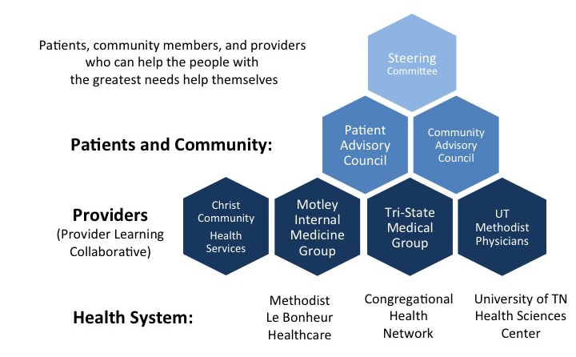

Since then, patients, caregivers, community members, and providers have worked together in Whitehaven, Tennessee to galvanize efforts to address and reverse the diabetes epidemic. Since 2009 the Coalition has sought to develop both outpatient physical space devoted to a comprehensive **Diabetes Wellness and Prevention Center** on the Methodist South Hospital campus and the patient, provider, and research collaboration necessary to transform diabetes care in Whitehaven from a focus on reactive, rescue care to a focus that is truly patient-centered and mobilizes and engages the entire community.

1. **Mission, Vision & Goals**

Our Mission

Our mission is to provide short-term, targeted care for chronically ill patients and families in our community by working with the entire care team and empowering patients to take personal responsibility for their health.

Go to Our: Vision | Goals

Our Vision

Our vision is to create a culture of health and well-being in our community that will lead people to take care of their health, will help people recognize when illnesses are becoming worse, and will improve the overall health of our community.

Go to Our: Mission | Goals

Our Goals

* Educate you on how to manage your chronic illness
* Help you get the care you need
* Help you manage your illness so you can stay out of the hospital and feel better
* Help you transition from the hospital to your home or other place of care
* Care for you in an environment that's patient- and family-centered
* Serves as a resource for primary care doctors in our community

Go to Our: Mission | Vision

1. **Participate**

Participate

Help us overcome diabetes one step at a time. If you are interested in participating in the Diabetes Wellness & Prevention Coalition, please contact us.

Go to: CAC | PLC | Steering

Patient Advisory Council (PAC) –The PAC meets monthly to advocate for patient-driven lifestyle change and empower people with diabetes or at risk for diabetes. The PAC works to make sure that Diabetes Wellness & Prevention Center programs and activities are centered on true patient needs. To participate in the PAC, or for more information, please contact:

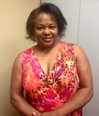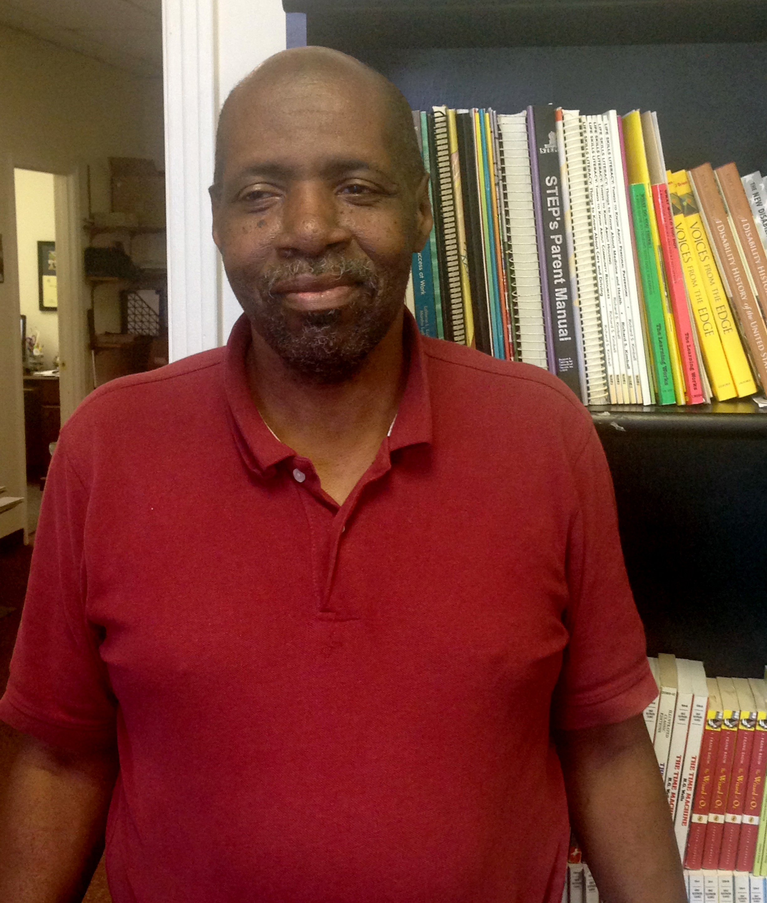

Ruthie Tate, Co-Chair Douglass Hall, Co-Chair

901-849-4561 901-644-9698

[ruthieltate@yahoo.com](mailto:ruthieltate@yahoo.com) doughallc@gmail.com

Go to: PAC | PLC | Steering

Community Advisory Council (CAC) –The CAC meets quarterly to make sure Diabetes Wellness & Prevention Center programs help address true community needs and take full advantage of existing community resources. The CAC also works to spread and share successful Coalition programs with other people and communities working to overcome diabetes one step at a time. To participate, or for more information, please contact:

Delois Broady, Co-Chair -[delois.broady@mlh.org](mailto:delois.broady@mlh.org)

Phebe Mclin, Co-Chair -phebe.mclin@gmail.com

Go to: PAC | CAC | Steering

Provider Learning Collaborative (PLC) –The PLC meets bi-monthly to work together through the Whitehaven DWPC to improve diabetes care and promote wellness for people with diabetes or at risk for diabetes and its many complications in the Whitehaven area. Through the PLC, providers learn and share: 1) best practices in diabetes care; 2) practice data on diabetes care performance; 3) diabetes practice improvement methods; and 4) ways to identify and overcome barriers to best diabetes care. To participate, or for more information, please contact:

Dr. Helmut Steinberg, Co-Chair -[hsteinb1@uthsc.edu](mailto:hsteinb1@uthsc.edu), 901-448-5240

Dr. Todd Motley, Co-Chair [-motleyintermed@bellsouth.net](mailto:-motleyintermed@bellsouth.net) (or contact Vicky Nelson, [Vicky.Bonner@mlh.org](mailto:Vicky.Bonner@mlh.org), 901-332-8547)

Go to: PAC | CAC | PLC

Steering Committee –The Steering Committee meets quarterly to oversee, direct, and help implement the programs and activities of the Diabetes Wellness and Prevention Center. To participate, or for more information, please contact:

Dr. James Robinson, Co-Chair -James.Robinson@mlh.org (or contact Sibyl Meyers-Williams, Sibyl.Meyers-Williams@mlh.org, 901-516-3081)

Dr. Jim Bailey, Co-Chair [–jeb@uthsc.edu](mailto:–jeb@uthsc.edu), 901-448-2475

1. **Services**

Services

Our highly skilled care team and provider partners can help you understand and manage your diabetes. We provide:

* Regular Comprehensive Exams
* Education on how to manage your condition
* Help connecting to resources
* Tools to monitor and manage your condition
* Help communicating with your doctor
* Help understanding and using benefits provided by health plan and community agencies
* Personal check-up calls between visits

Contact our provider partners listed below an appointment today:

UT Methodist Physicians, 1251 Wesley Dr. #151 -901-758-7888

Motley Internal Medicine Group, 1264 Wesley Dr # 606 -901-332-2277

TriState Medical Group, PLLC, 1264 Wesley Dr #405 -901-332-9632

Christ Community Health Services, Third Street Clinic, 3362 South Third St. -901-701-2510

1. **Get Started**

Get Started

Your doctor or health care provider can refer you to our Center. If you don’t have a referral, you can call 901-758-7888

To schedule an appointment for diabetes education, call 901-516-9000

What to Expect

If you are referred to the Center when you are in the hospital:

* Within 24 hours the nurse will introduce herself to you and explain the purpose, goals, and expectations
* Within 72 hours of leaving the hospital, you will receive a follow-up phone call
* A follow-up appointment will be scheduled for you within 3-5 days after leaving the hospital.
* Our care team will then make follow-up calls once a week

Directions[Open in App](http://maps.apple.com/?q=35.03239,-90.020438)

From I-240 W:

* Merge onto I-240 W toward Memphis.
* Merge onto I-240 W via EXIT 10A towards Jackson, Miss.
* Turn slight left onto Millbranch Rd.
* Take the 2nd right onto East Brooks Rd.
* Turn left onto Elvis Presley Blvd/US-51 S/TN-3.
* Turn left onto Wesley Drive.

1300 Wesley Dr. is on the left.

1. **Stories**

Our Stories

Ruthie's Story

Hi, my name is Ruthie Tate. I live with diabetes. Since I became a diabetic my lifestyle changed drastically. At first, I was in denial about the thought of just being a diabetic and all of the different barriers that come with being there. I was going to see my physician but I wasn’t doing all of the things that I needed to do to just keep myself healthy and living a good life. I wasn’t taking my medication like I should. My doctor always told me to take my prescriptions and I thought yes I’m going to take it but in the end I didn’t take it like I should. I went to the doctor and my doctor told me, “I can help you now, but once your body parts begin to fail I won’t be able to help you then.” It was then that I made a commitment to myself that I would do all that I could for myself to live a healthy lifestyle. I started taking my medications daily, I started counting my total carbohydrates at each meal so that my A1C levels wouldn’t go all out of whack. Overall, after I made that commitment to myself, I am improving daily. My A1C level was where it was supposed to be at my last doctor’s visit. So, I’m trying to take control of my life. And I would just like to tell others, if you are a diabetic person, try to become educated about the disease. Do your part to help yourself. You are going to have other people there to support you, but the number one thing is you have to support yourself.

[Right Column]



**Ruthie Tate**

Patient Advisory Council Co-Chair

Pastor William Burks’ Story

**Pastor William Burks**

Patient Advisory Council Member

I was diagnosed with diabetes approximately 3 years ago, and to say the least it was devastating to get that information. But I decided to not let diabetes rule my life, but for me to take control of the situation.

Diabetes, to me, is a journey, where in you control how far you go. You control what you do on the journey. So I have been very, very blessed in that I do check my glucose, on a daily basis, I check it periodically after I've eaten certain foods. Because I do not, I don't eat a lot of things that the average person eats. I do consume a lot of vegetables. I eat a lot of green vegetables. I eat a lot of fruit. I am specific about which fruits I eat and what time I eat them. I drink at least 96 ounces of water on a daily basis. I want you to know that this not a death sentence. Being diabetic is not a death sentence. You can do something about your condition. Make up your mind, get you a partner, someone who can work with you. Someone who will help keep you encouraged on your journey. And then what you can do is take charge of the situation. Eat right, get plenty rest, plenty of exercise, and enjoy your life—those things really make the differences in how you do as a diabetic.

Douglass Hall’s Story

The doctor did initially tell me that blindness could very well end up being one of the drawbacks if I didn’t get it under control…the biggest challenge was taking the diagnosis a little bit more seriously…when you don’t have something beating you over the head, like an open sore that might be getting worse that you can physically see, the tendency is to be a little bit dismissive…while it has been challenging, I have been able to manage this thing a whole lot better.

[Right Column]



**Douglass Hall**

Patient Advisory Council Co-Chair

1. **Improve Care**

**Join us in the effort to improve care in the Mid-South!**

The Diabetes Wellness and Prevention Coalition (DWPC) in collaboration with the University of Tennessee Health Science Center operates the *DWPC Registry* to track processes and outcomes of care and improve care for people living with diabetes or at risk for diabetes in the Mid-South. The *DWPC Registry* fully qualifies as a *Specialized Registry* for the purposes of achieving *meaningful use* of electronic health records. We have begun accepting data as a specialized registry and will be using the data to improve population health outcomes. The *DWPC Registry* also undergirds our practice improvement work through the Patient-Centered Outcomes Research Institute (PCORI)-funded *Management Of Diabetes in Everyday Life (MODEL) Program*. We also provide practice feedback of quarterly practice improvement reports to participating providers.

**Figure: Diabetes Wellness and Prevention Coalition Registry Schematic**

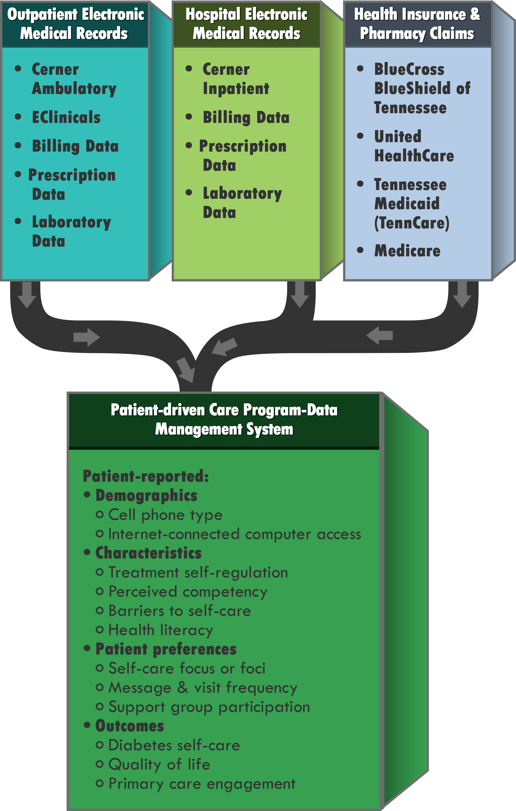

We are able toreceive electronic data generated from certified electronic health record technology (CEHRT) through appropriate secure mechanisms. The *DWPC Registry* has a registration of intent process that takes clinics and other providers through test and validation and a process to move into production. We provide participating providers with appropriate documentation in order to begin this process and we notify them by email on a regular basis of the status of their feeds to the registry and whether they are currently meeting our criteria for "Active Engagement".

To participate in the *DWPC Registry,* or to request more information, contact Bonnie Binkley, MA at: [info@mydiabetescenter.org](mailto:info@mydiabetescenter.org), (901) 448-4168

1. **My Care Tools**
   1. **Diabetes Education**
   2. **Physical Activity**
   3. **Caring for Diabetes**
   4. **My Diabetes Apps**
   5. **Patients Like Me**

Diabetes Education

Methodist helps you to take control of your diabetes through classes led by nurse practitioners, pharmacists and dietitians at several locations.

Programs at Methodist South

Diabetes Education Program

Fridays at Noon - 1:00 pm for 5 weeks

Methodist South Hospital

Free of Charge; registration required

Contact Annette Caple at 901.516.3774 or 901.418.0278

As a part of this free, five-week clinic, our specialized team of nurse practitioners, pharmacists ad dietitians will proves blood pressure checks, weight monitoring, nutrition counseling, education, resource referrals, support, and consultations.

Programs at Methodist Germantown

[Left Column]

Diabetes Classes

If you've been diagnosed with diabetes, classes may be covered by your insurance. Methodist Germantown's diabetes services have received national recognition from the American Diabetes Association. Our diabetes coordinators can also meet with you one-on-one to discuss your diet and insulin medication.

[Middle Column]

Gestational Diabetes Class

Tuesdays | 1:00 - 4:00 p.m.

Methodist Le Bonheur Germantown Annex

(Across Poplar Ave. from the hospital)

Registration and payment required. Call 901.516.9000

Expectant mothers receive glucose-meter training, meal planning and a gestational diabetes management plan in this three-hour class.

[Right Column]

One-on-One Diabetes Education - Insulin Training

Individual appointments available. Payment required.

Call Kristy Merritt at 901.516.6616

This is a one-on-one educational session for insulin administration only. The training session lasts between 30 minutes and an hour.

Diabetes Education Class

Thursdays | 9:30 a.m. - 12:30 p.m. or 2:00 p.m. - 5:00 p.m. (Two sessions available)

Methodist Le Bonheur Germantown Annex

(Across Poplar Ave. from the hospital)

Registration and payment required. Call 901-516-9000

Following recommendations from the American Diabetes Association, this customized teaching plan covers meal planning, monitoring, medication and exercise. Patients meet individually with our staff to determine educational goals and the teaching plan. After attending classes, patients again meet individually with a diabetes coordinator for follow-up. The program may be completed in 1-12 months.

Insurance Coverage for Classes

For classes that require payment, most insurance plans cover the cost of diabetes education at the request of your physician. Check with your insurance company to find out if your plan covers classes.

If yes, ask your doctor to complete the diabetes class referral form (PDF) and fax it to 901.516.4900.

Go to: Physical Activity | Healthy Eating | Caring for Diabetes

Physical Activity

Physical activity is another important part of your diabetes management plan. When you exercise, your muscles use sugar (glucose) for energy. Regular physical activity also helps your body use insulin more efficiently.

These factors work together to lower your blood sugar level. The more strenuous your workout, the longer the effect lasts. But even light activities--such as housework, gardening or being on your feet for extended periods--can improve your blood sugar level.

What to do:

* Talk to your doctor about exercise plan.
* Keep an exercise schedule.
* Stay hydrated.

Gym Memberships and Classes

* YMCA
* Group Fitness
* Local Events

Go to: Diabetes Education | Healthy Eating | Caring for Diabetes

Healthy Eating

Healthy eating is a cornerstone of health living--with or without diabetes. But if you diabetes, you need to know how foods affect your blood sugar levels. It’s not only the type of food you eat but also how you eat and the combinations of food types you eat.

What to do:

* Learn about carbohydrate counting and portion sizes.
* Make every meal well-balanced.
* Coordinate meals with medications.
* Avoid sugar-sweetened beverages.

Nutrition Classes, Farmer’s Market, Healthy Recipes

* Church Health Center
* Community Gardens

Go to: Diabetes Education | Physical Activity | Caring for Diabetes

Caring for Diabetes

* My Diabetes Health Assessment

Go to: Diabetes Education | Physical Activity | Healthy Eating

1. **Patientslikeme** (External Link)
2. **My Diabetes Apps**

My Diabetes Apps

Some of our patients’ favorite smart phone applications to help you manage your diabetes are available for download below. Try them out!